HARSHTON JUNIOR SCHOOL-MBALE
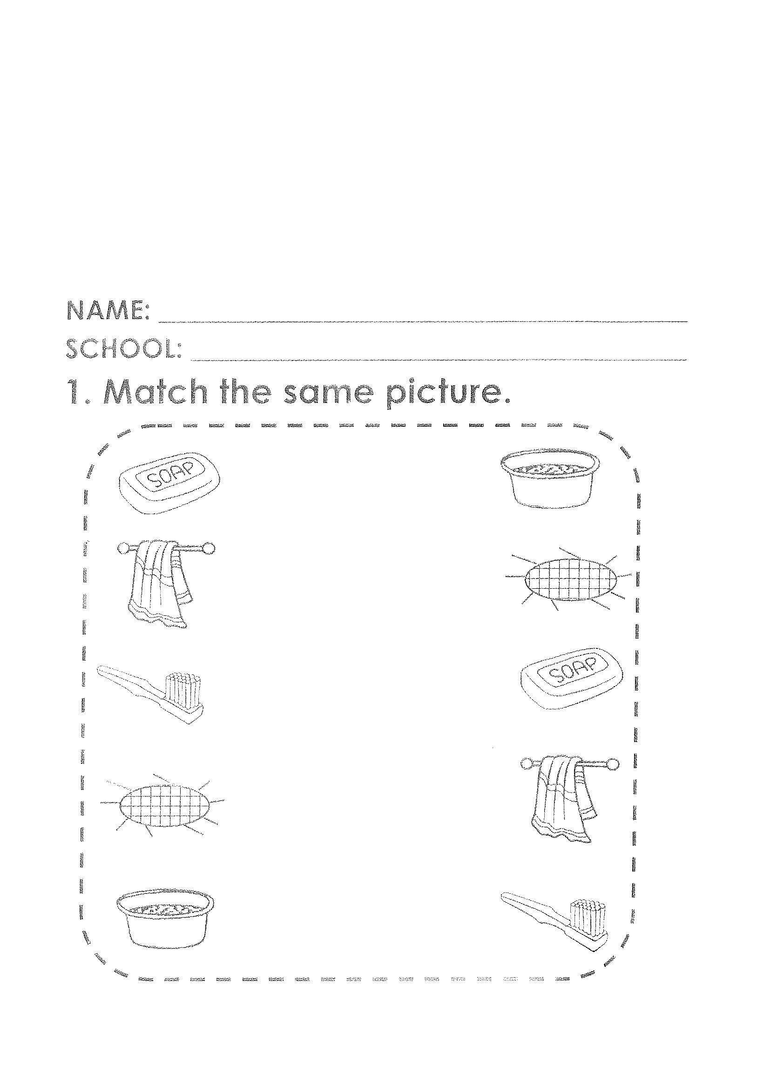


HOLIDAY PACKAGE TERM I-2023
FOR MIDDLE CLASS LEARNING AREA THREE
HJS-ACADEMIC BOARD
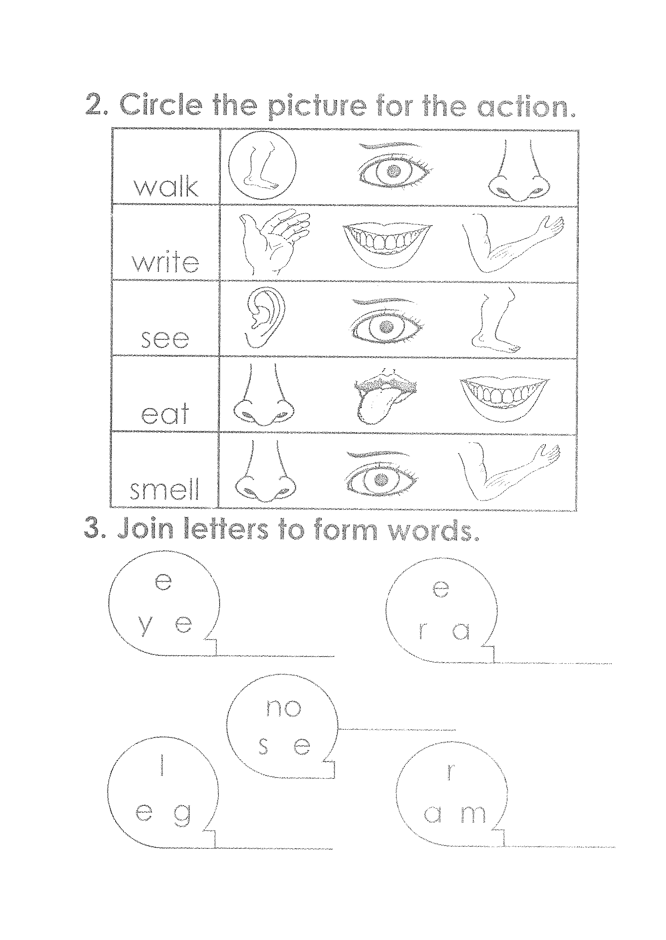

HJS- ACADEMIC BOARD
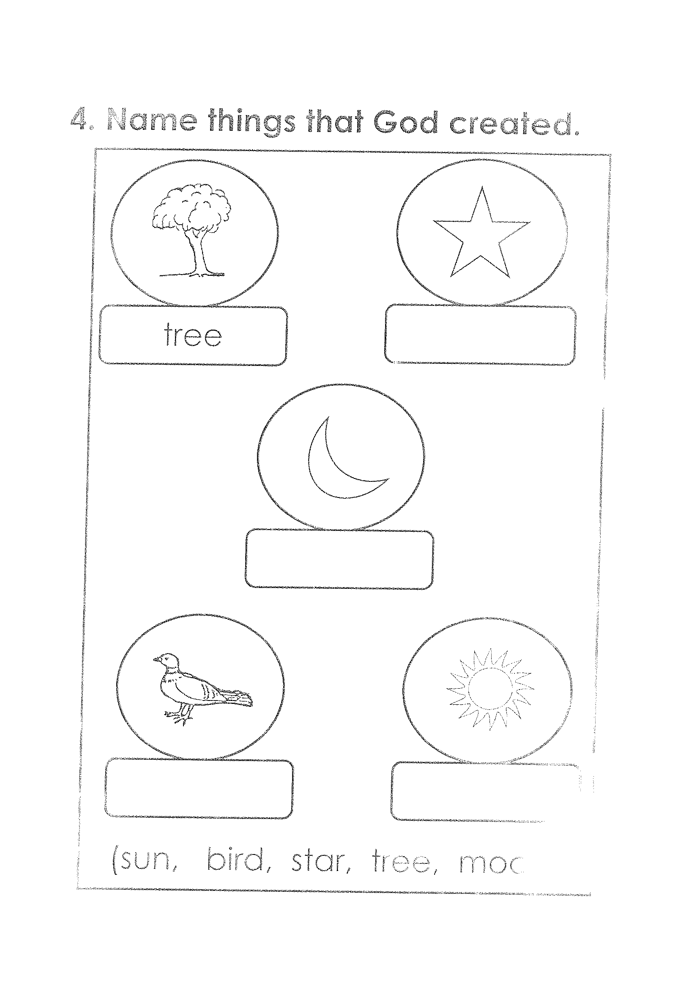

moon )
HJS-ACADEMIC BOARD
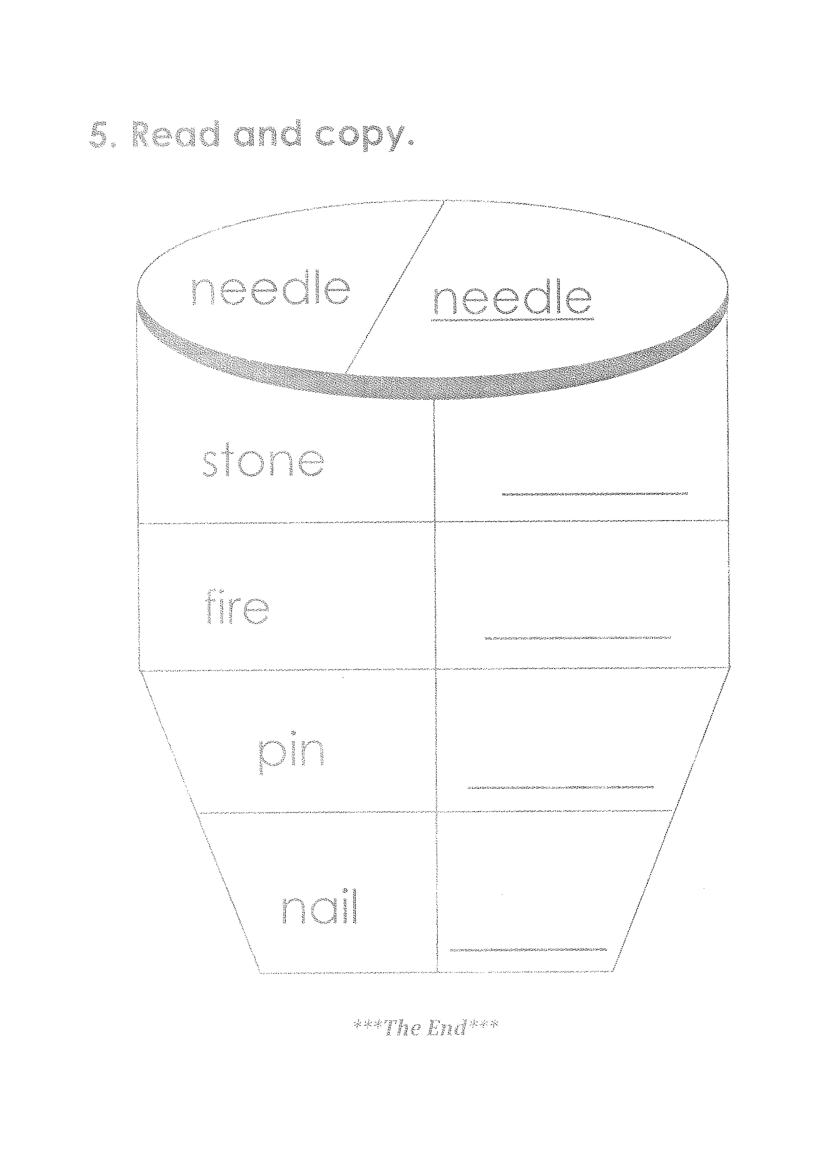

HJS-ACADEMIC BOARD
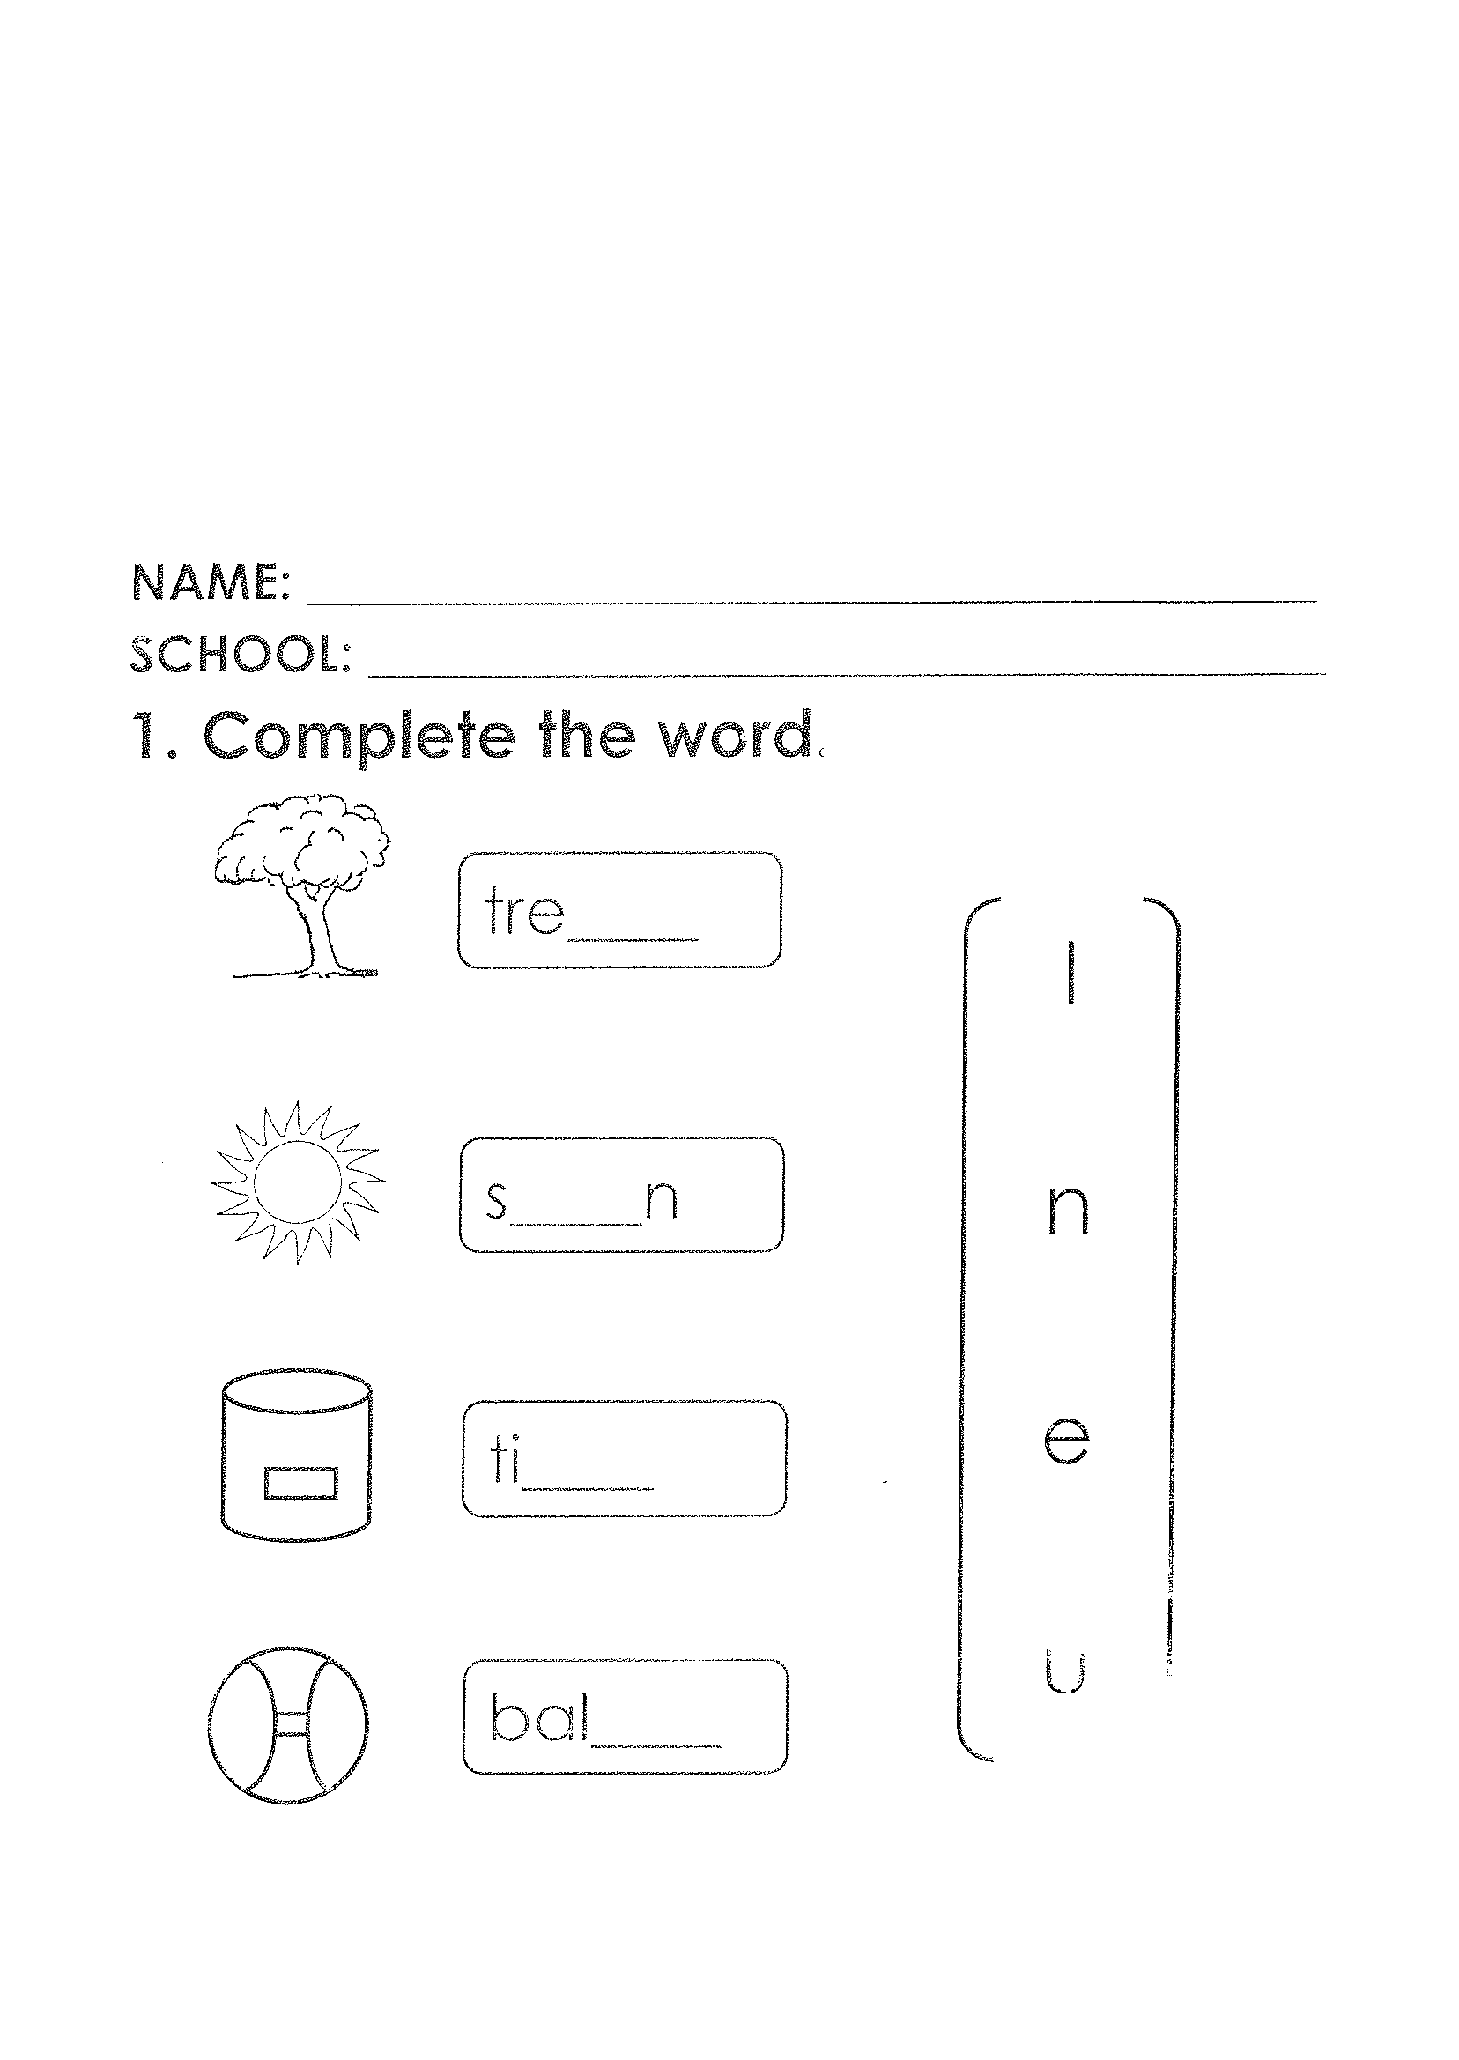

ENGLISH
HJS-ACADEMIC BOARD
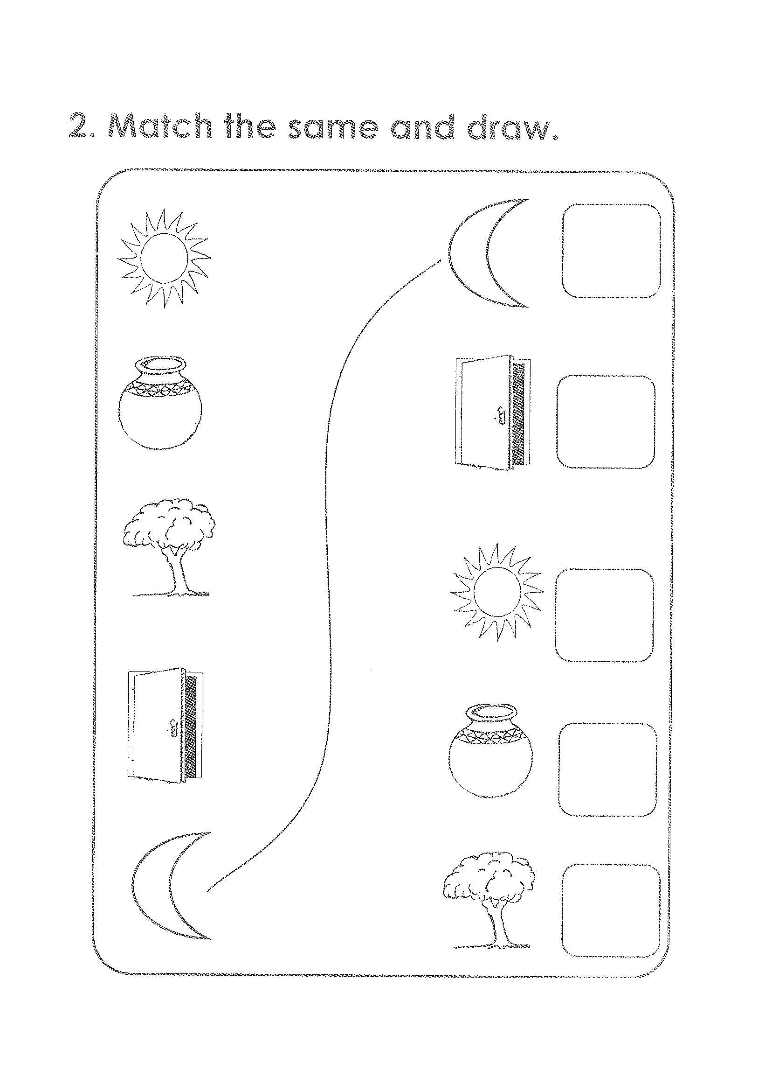

HJS-ACADEMIC BOARD
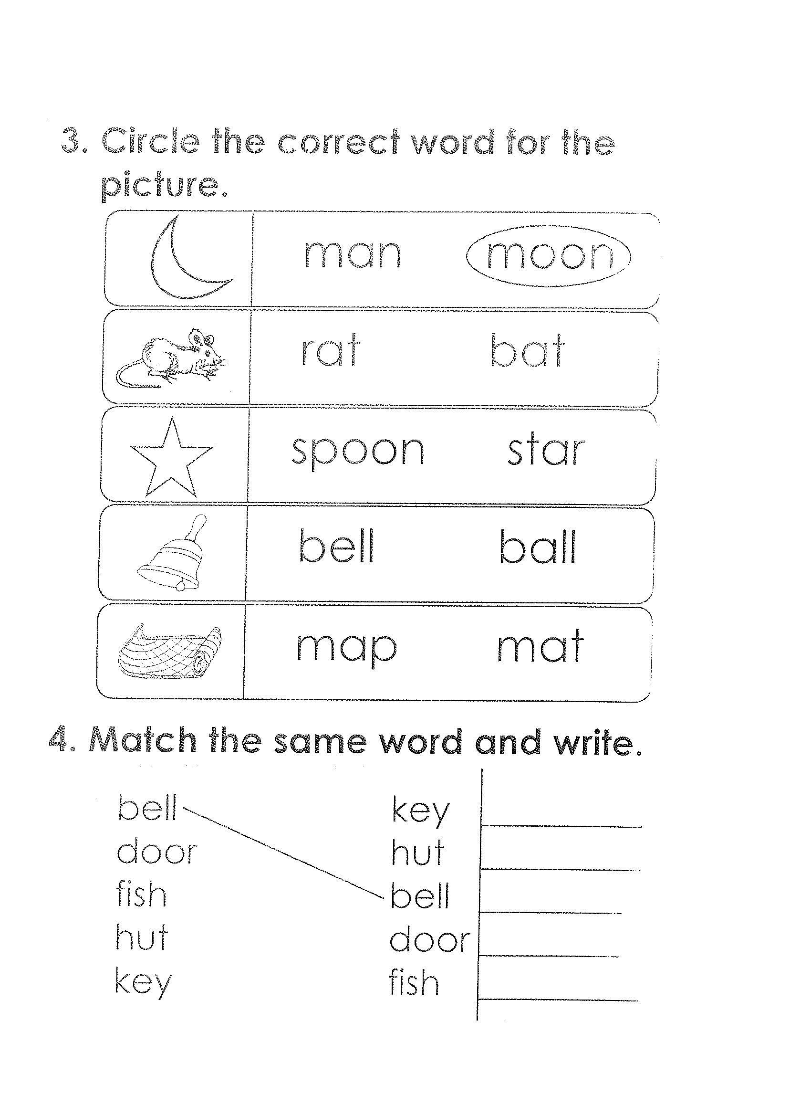

HJS-ACADEMIC BOARD
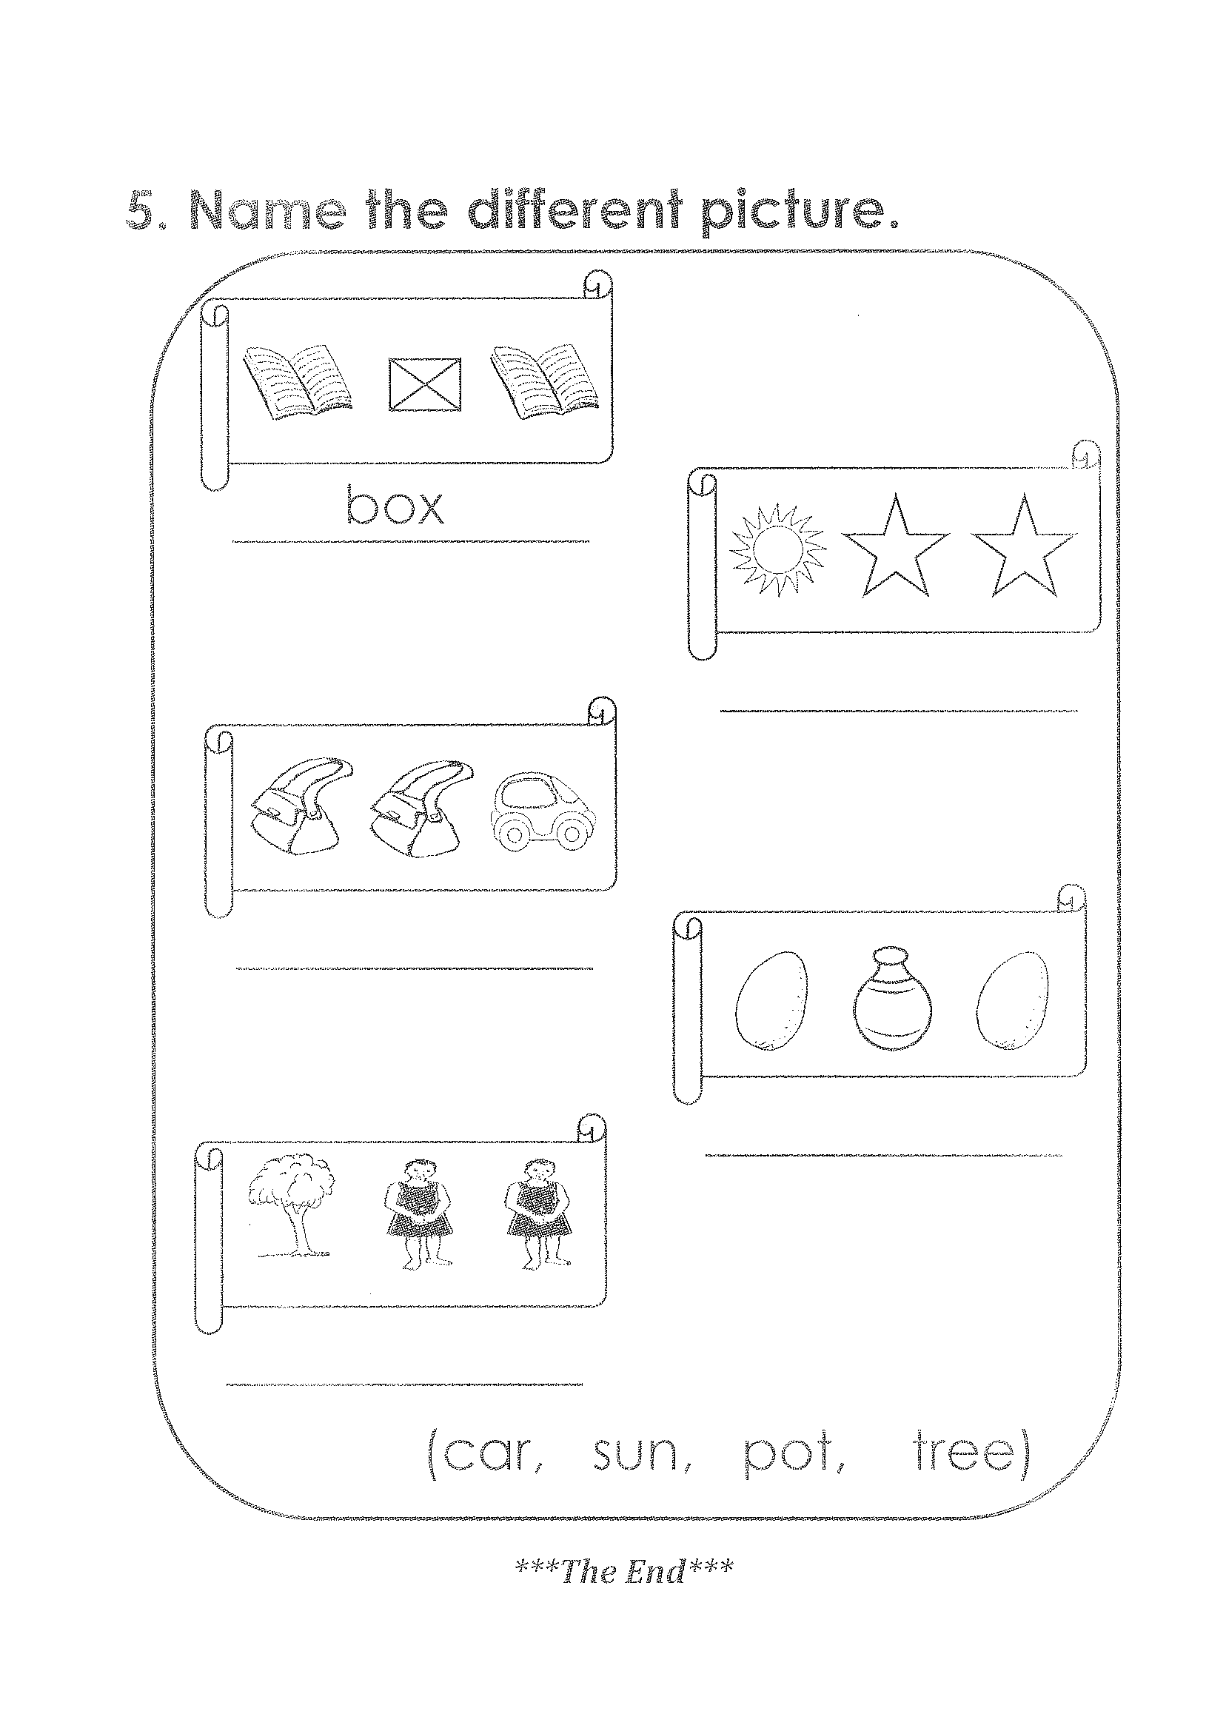

HJS-ACADEMIC BOARD

LEARNING AREA FOUR
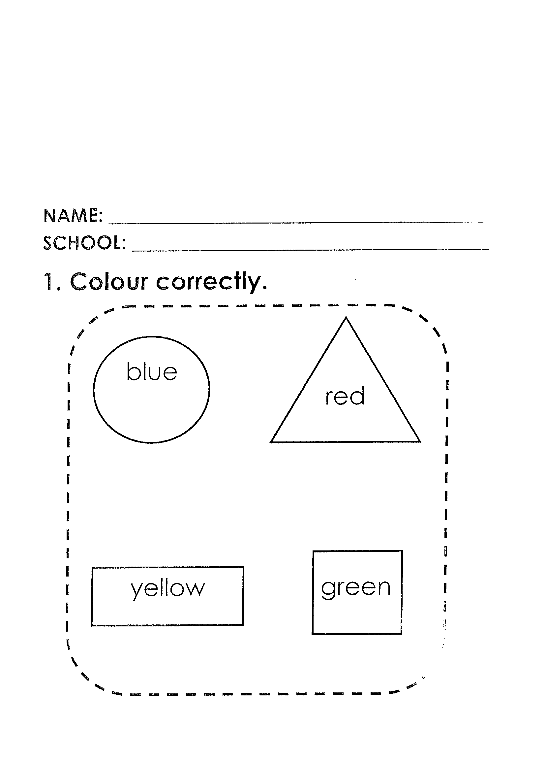

HJS-ACADEMIC BOARD
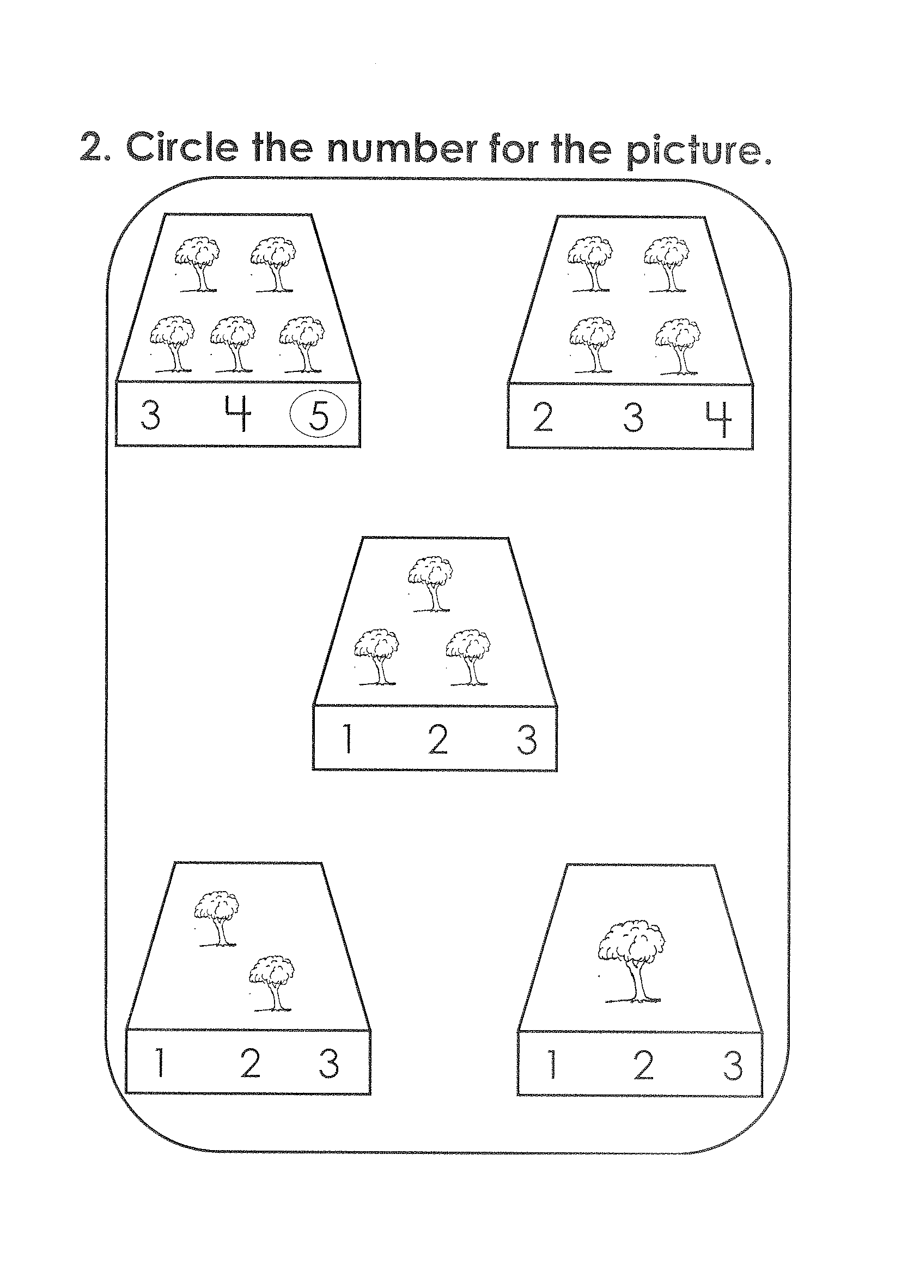

HJS-ACADEMIC BOARD
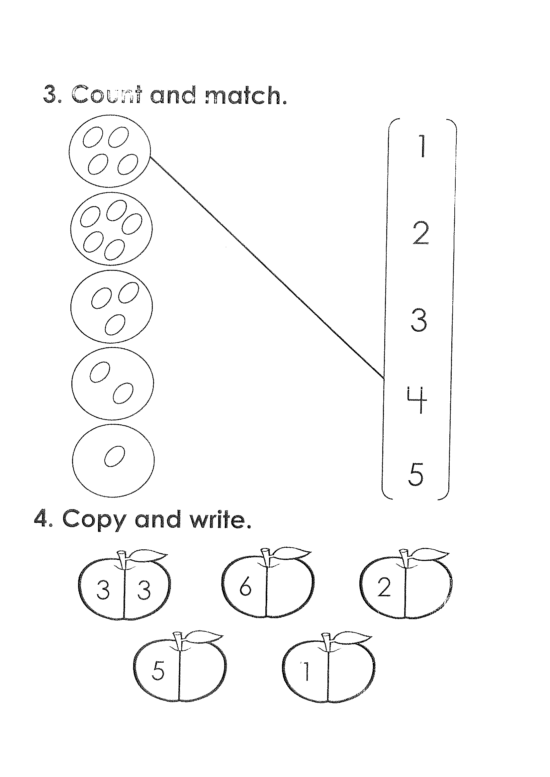

Count
HJS-ACADEMIC BOARD
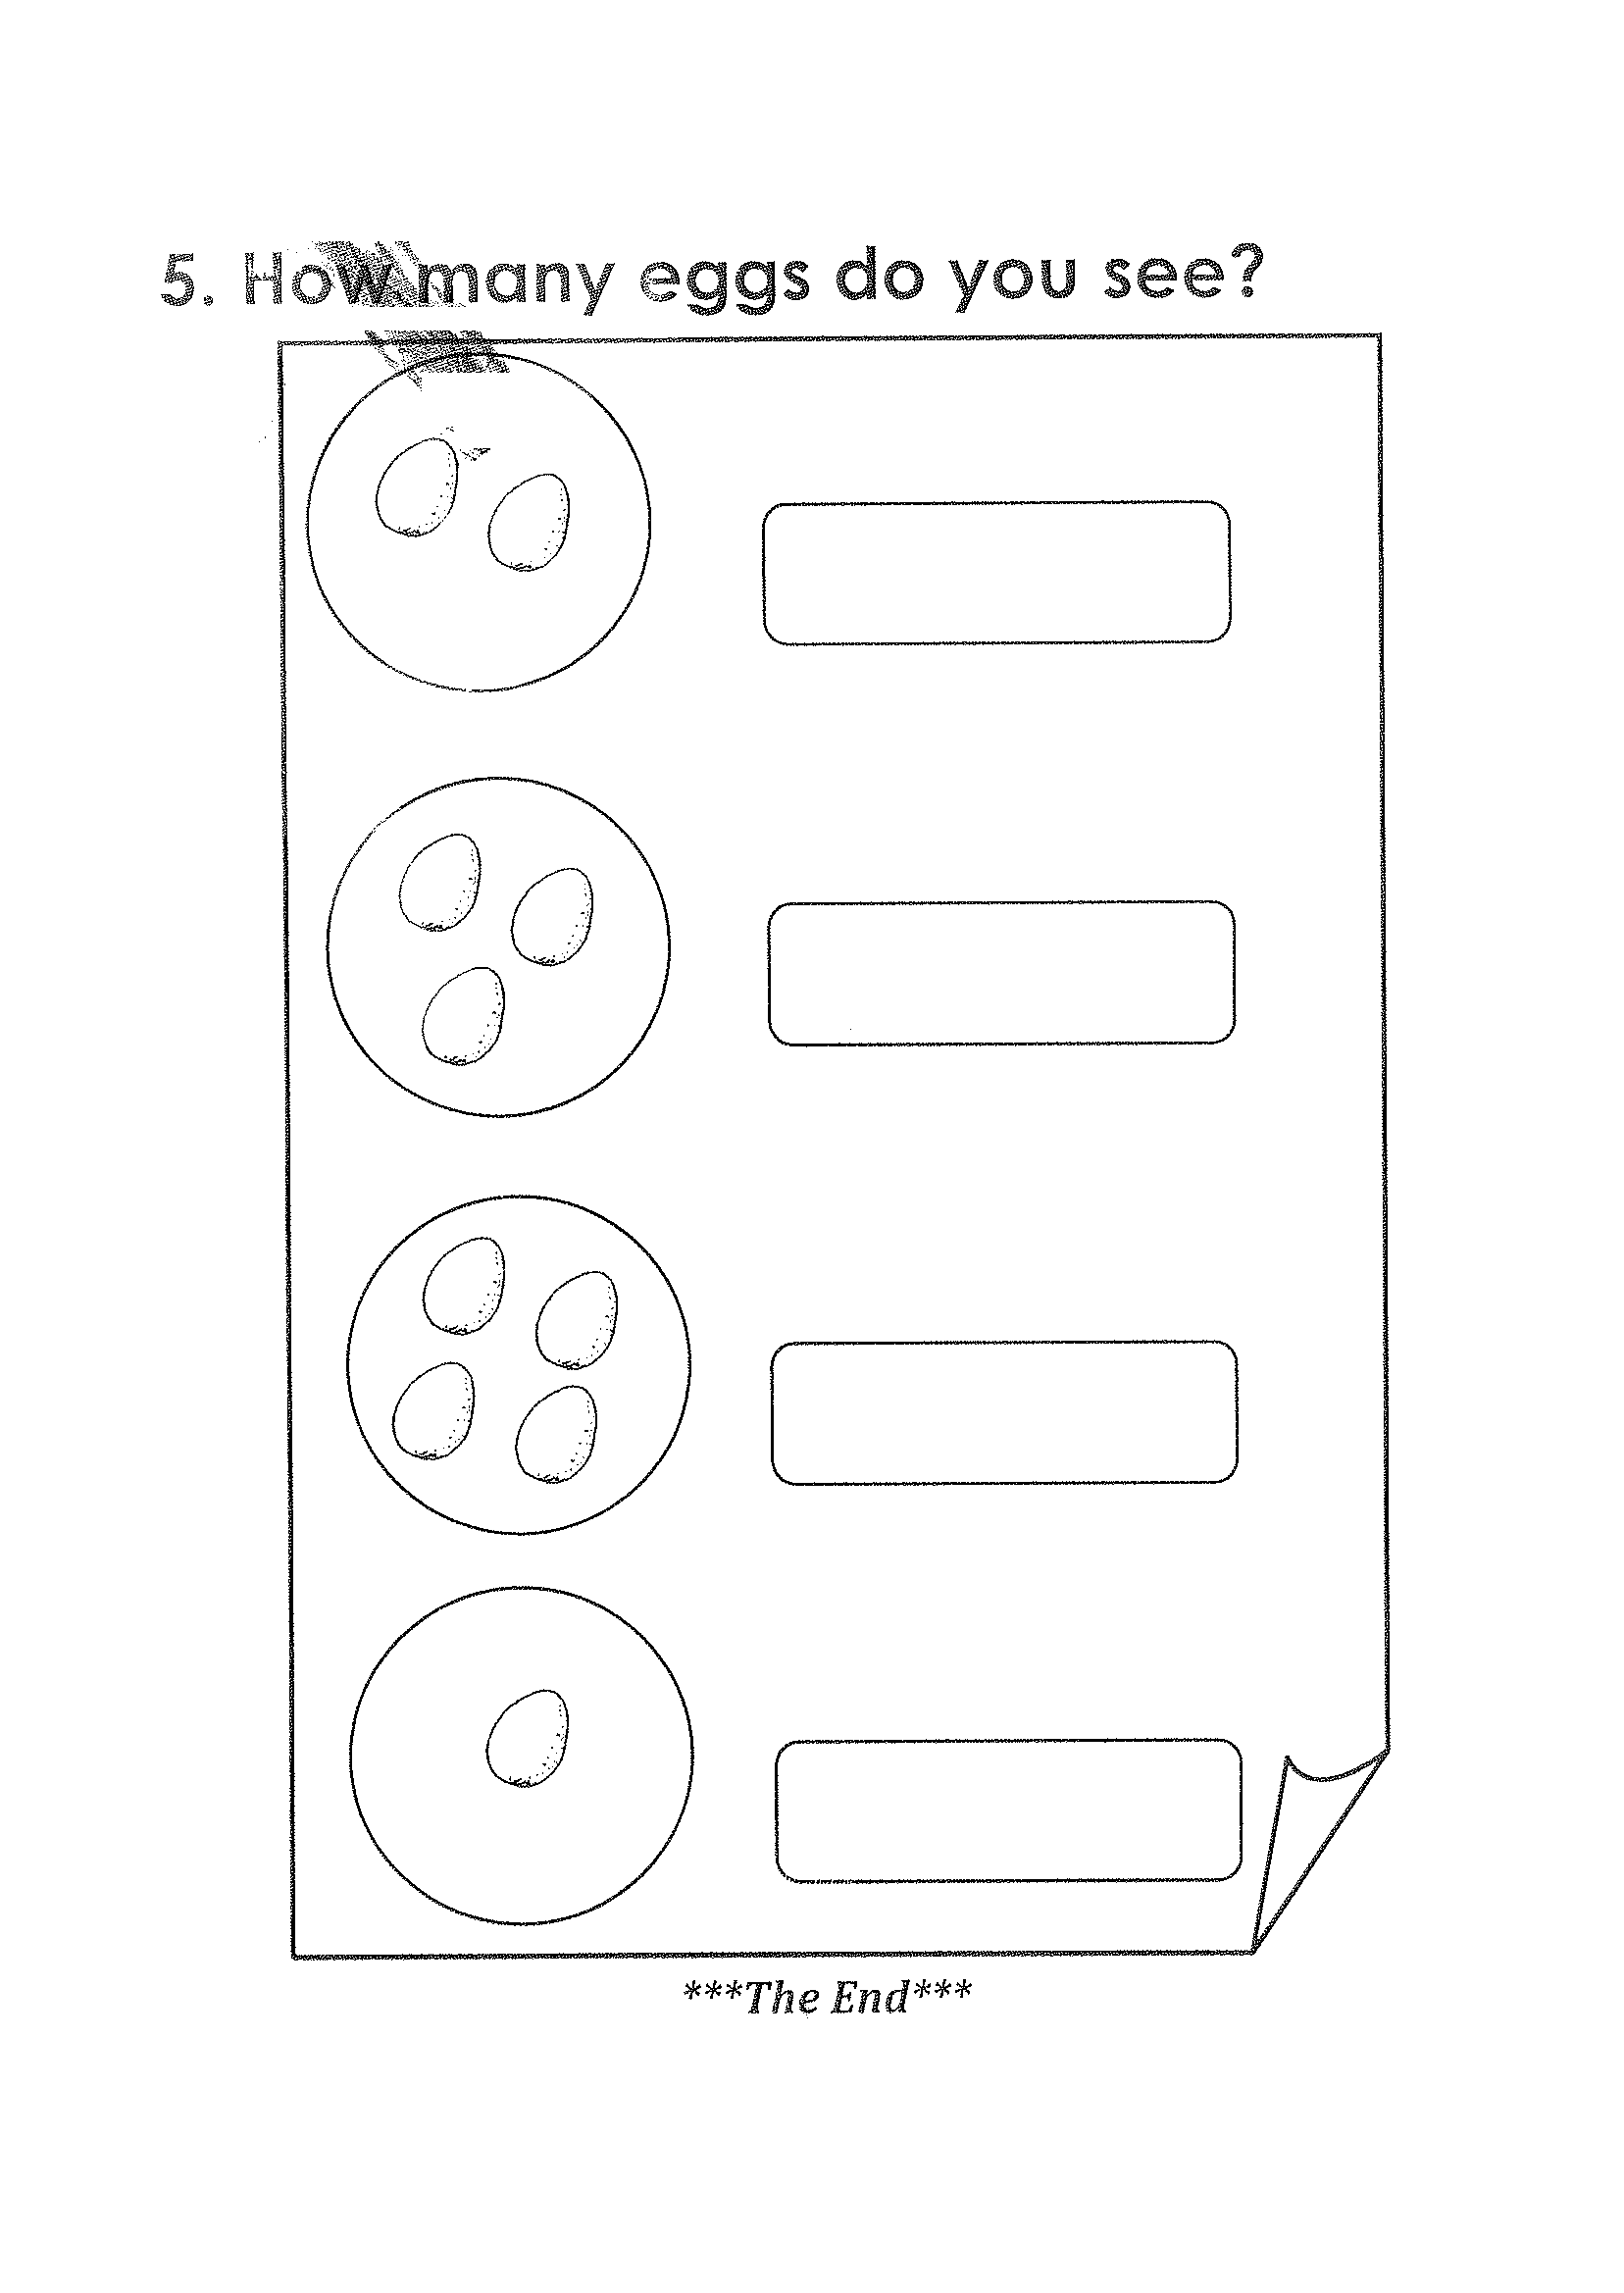

HJS-ACADEMIC BOARD

READING
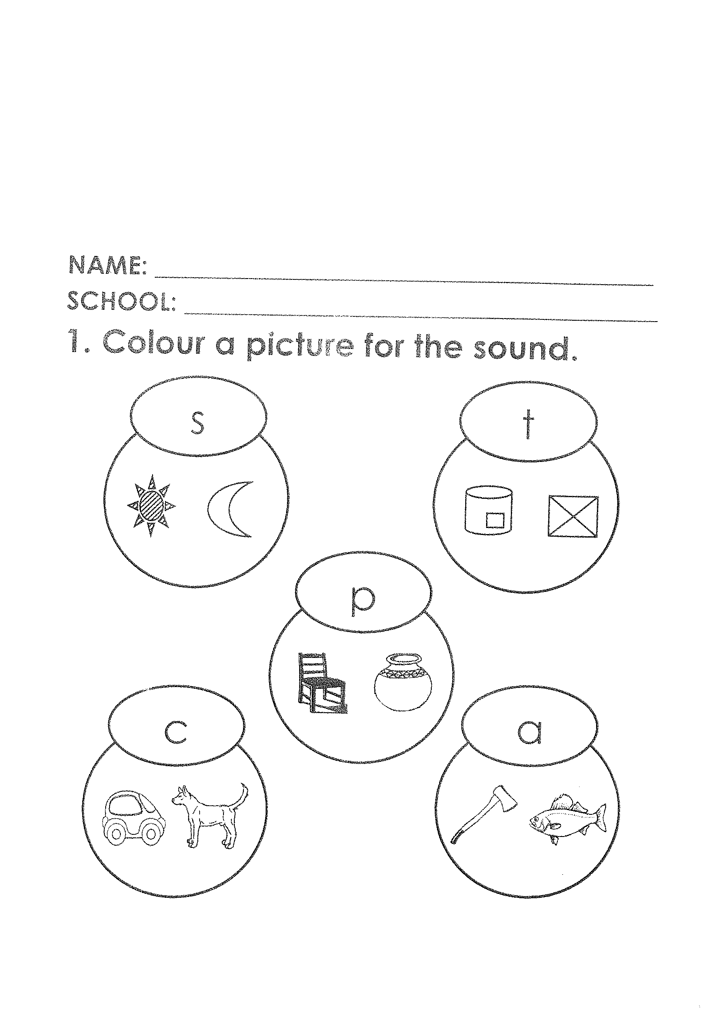

HJS-ACADEMIC BOARD
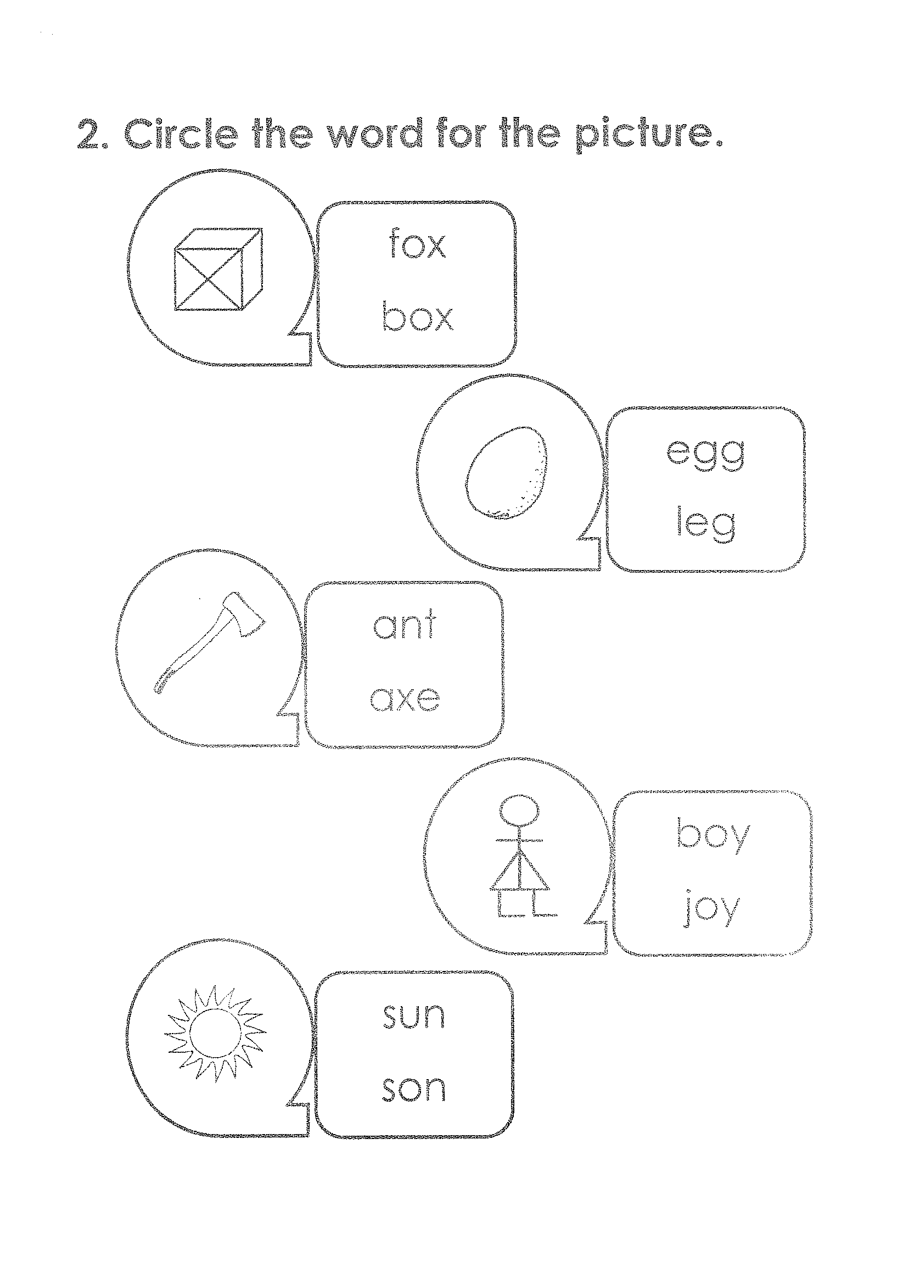

HJS-ACADEMIC BOARD
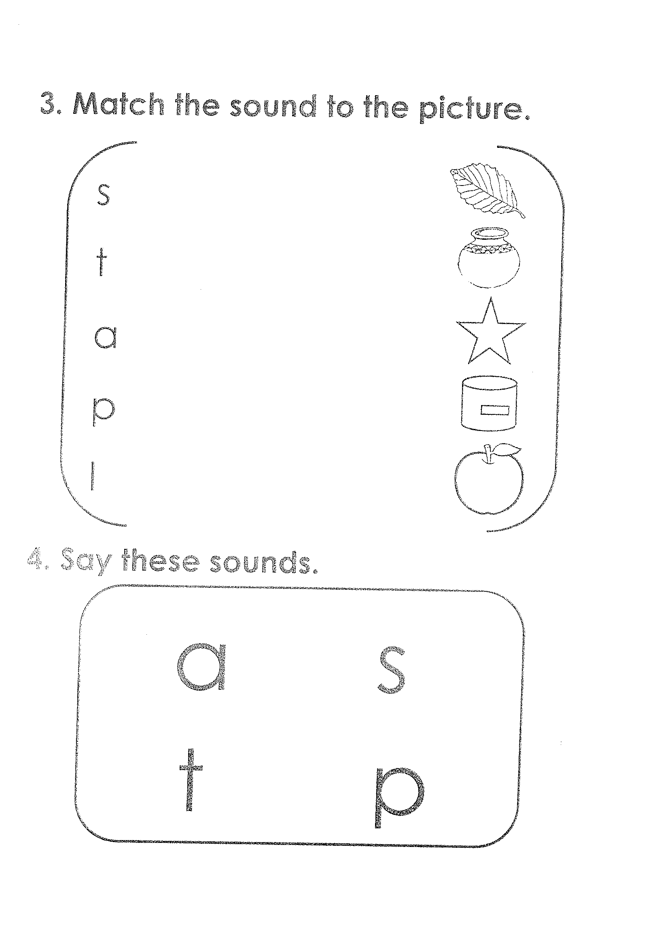

HJS-ACADEMIC BOARD
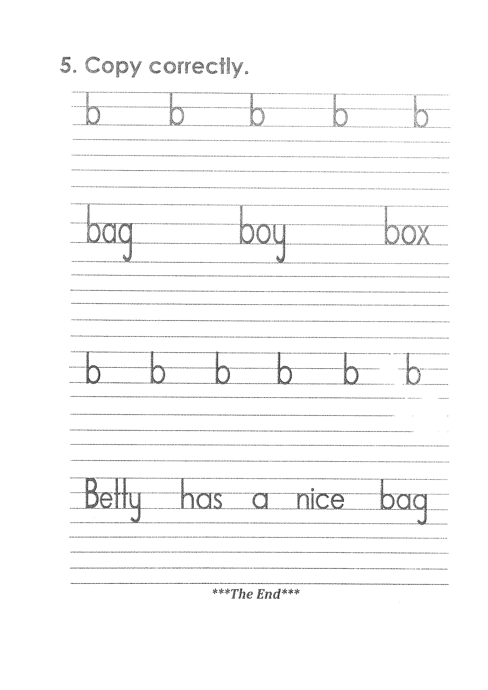

HJS-ACADEMIC BOARD
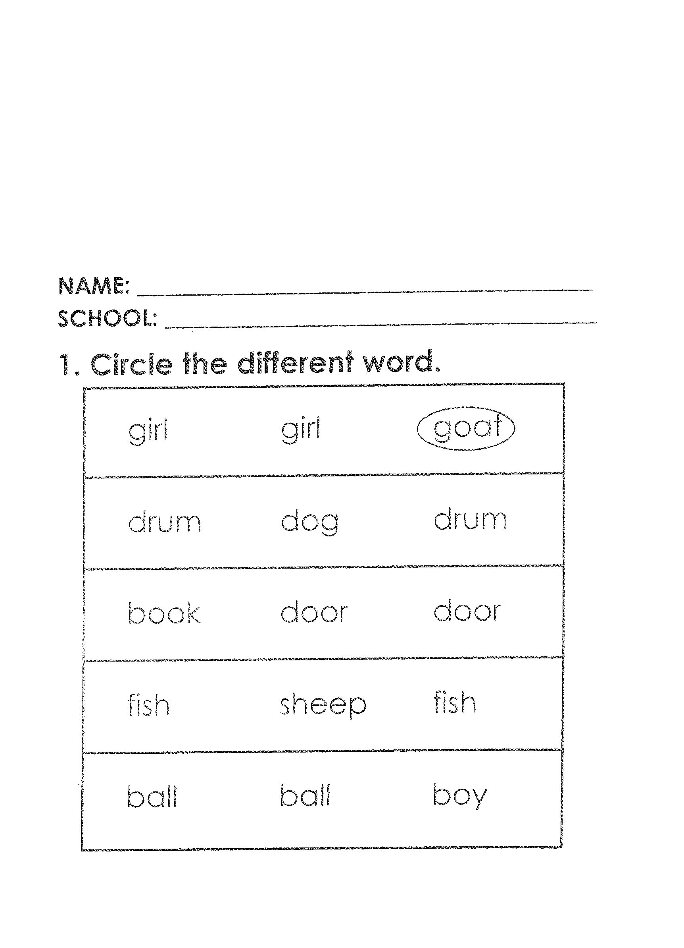
LEARNING AREA ONE

HJS-ACADEMIC BOARD
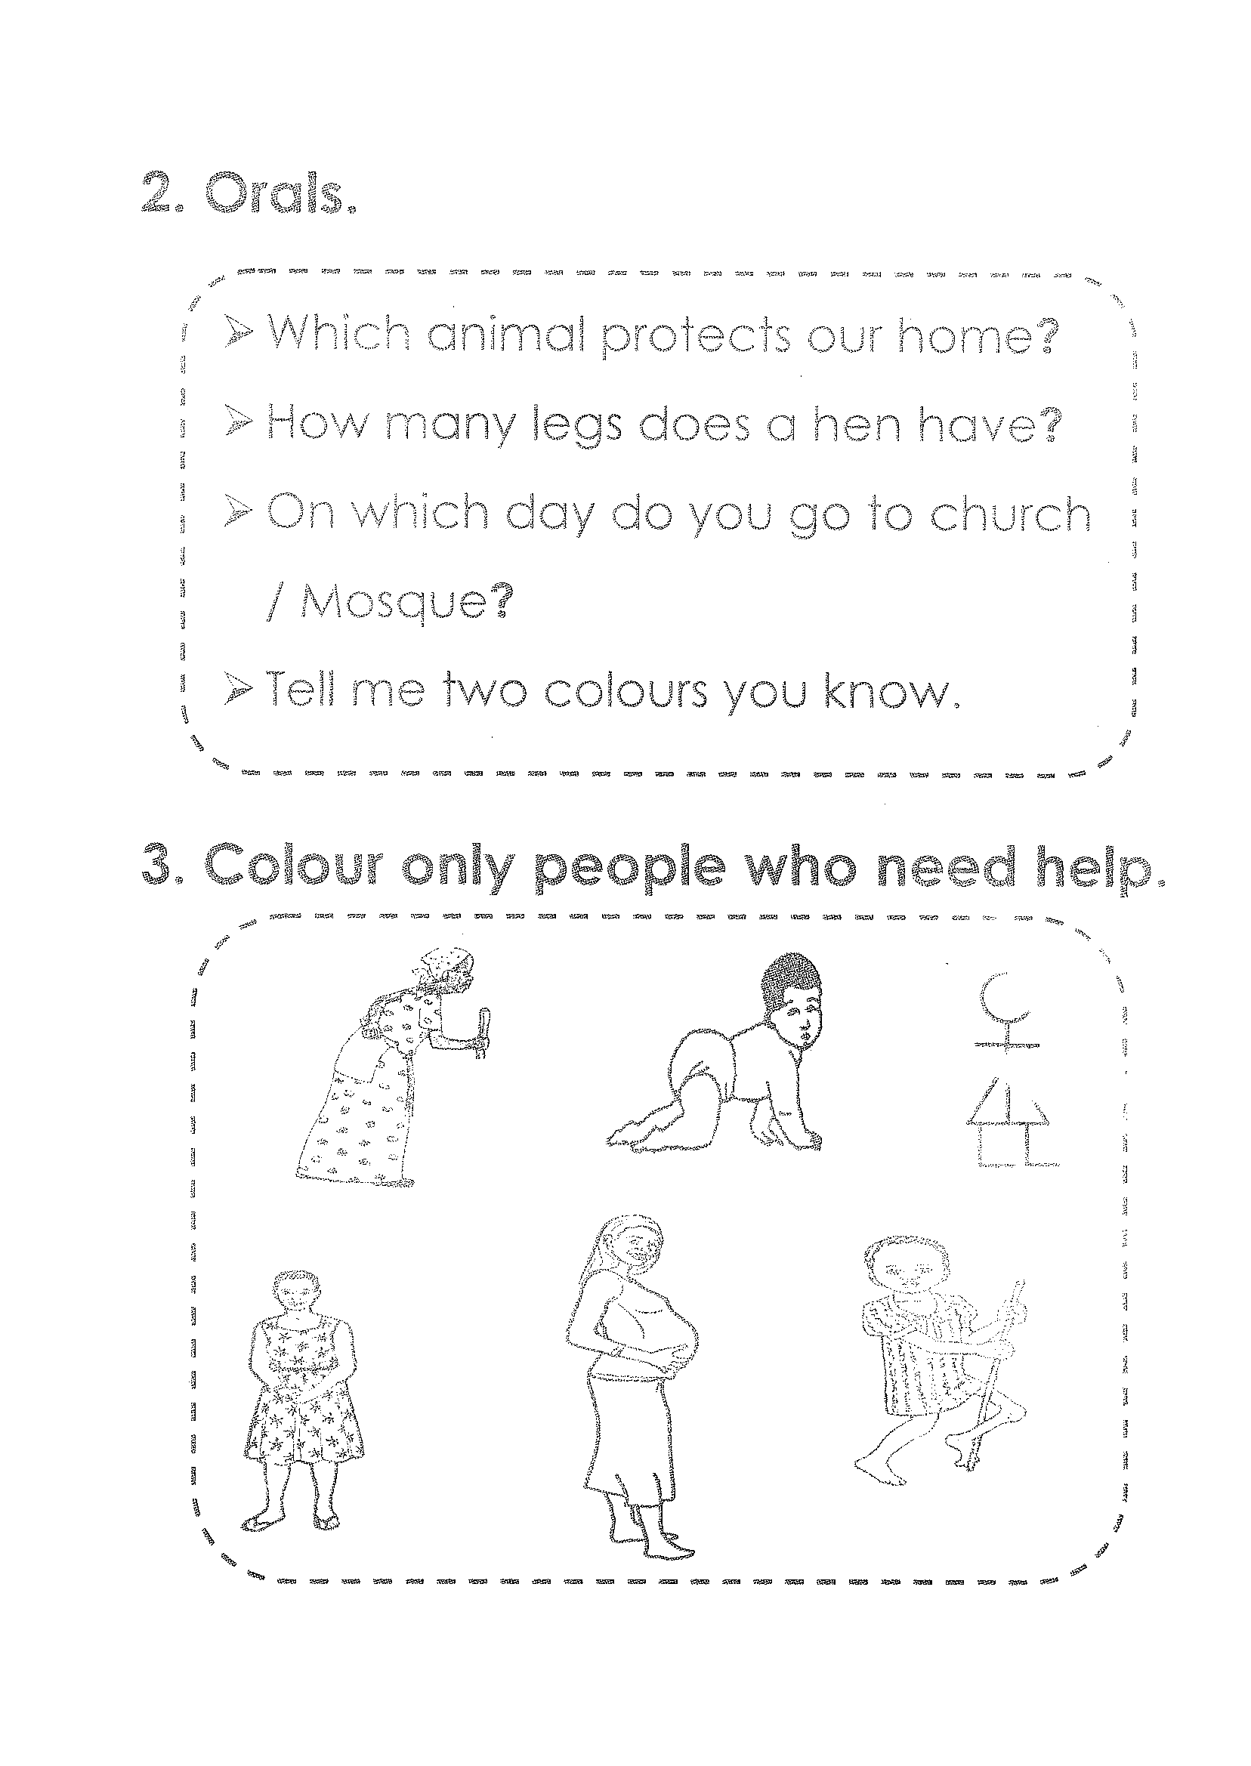

HJS-ACADEMIC BOARD
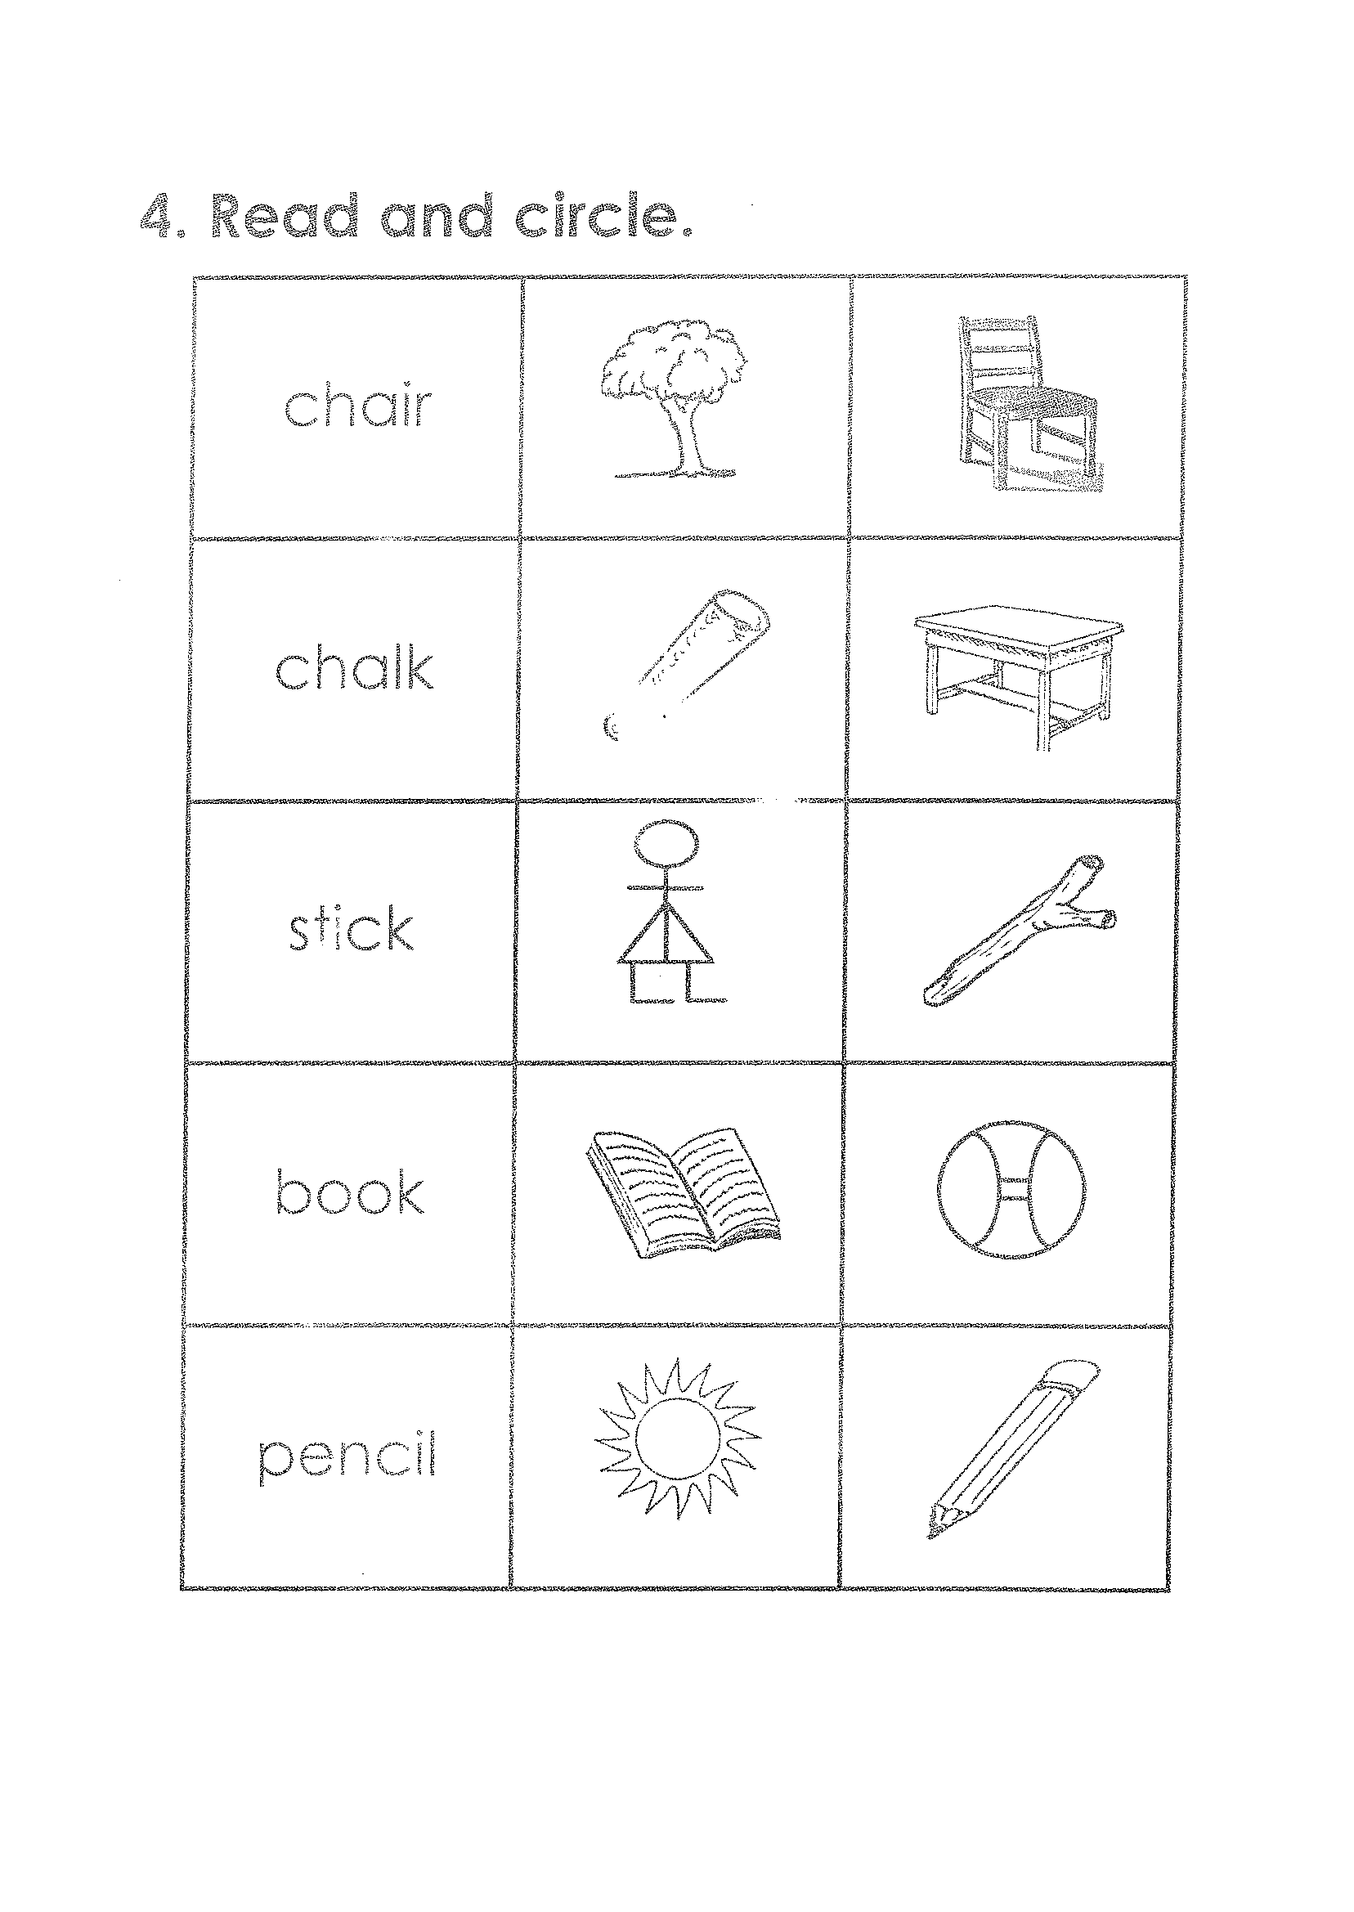

HJS-ACADEMIC BOARD
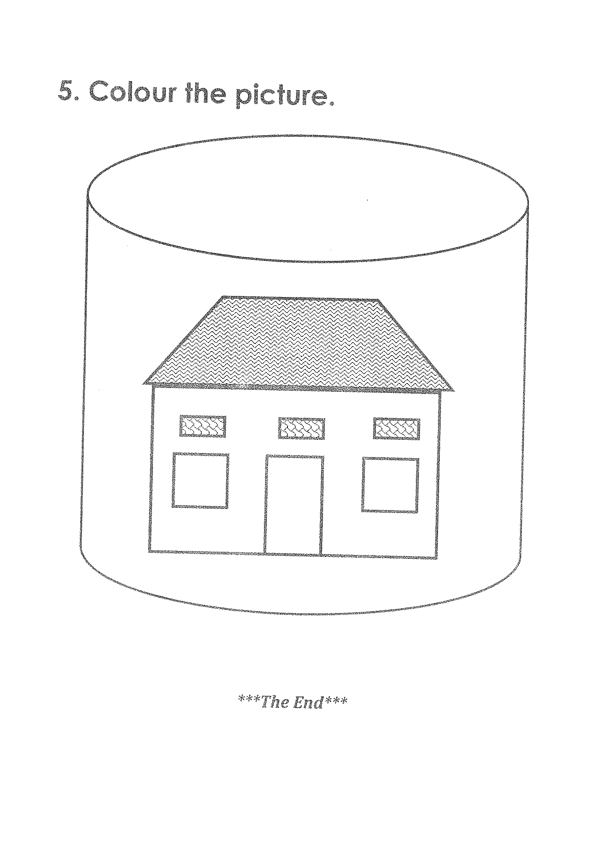

HJS-ACADEMIC BOARD

